# INTERNET PROGRAMMING LABORATORY

## (Cse-326)

K22mp group-2

# FInal report



**INDIAN ELECTRICITY WEBSITE**

**SUBMITTED BY:-**

* **ABHINAY GOUD (12201930)**
* **AAMIR ADNAN (12201985)**

•  **SHIVA REDDY (12201954)**

# **SUBMITTED TO:-**

**MS.SAKSHI**

## INTRODUCTION

Hypertext Markup Language (HTML) is the standard markup language for documents designed to be displayed in a web browser. It can be assisted by technologies such as Cascading Style Sheets (CSS)and scripting languages such as JavaScript. HTML elements are the building blocks of HTML pages. With HTML constructs , images and other objects such as interactive forms may be embedded into the rendered page. HTML provides a means to create structured documents by denoting structural semantics for text such as headings, paragraphs, lists, links, quotes and other items. HTML can embed programs written in a scripting language such as JavaScript, which affects the behavior and content of web pages. Inclusion of CSS defines the look and layout of content. The World Wide Web Consortium (W3C), former maintainer of the HTML and current maintainer of the CSS standards, has encouraged the use of CSS over explicit presentational HTML since 1997.

Web browsers receive HTML documents from a web server or from local storage and render the documents into multimedia web pages. HTML describes the structure of a web page semantically and originally included cues for the appearance of the document.

**CSS (Cascading Style Sheets)** is used to style and lay out web pages — for example, to alter the font, color, size, and spacing of your content, split it into multiple columns, or add animations and other decorative features. This module provides a gentle beginning to your path towards CSS mastery with the basics of how it works, what the syntax looks like, and how you can start using it to add styling to HTML.

JavaScript is a dynamic computer programming language. It is lightweight and most commonly used as a part of web pages, whose implementations allow client-side script to interact with the user and make dynamic pages. It is an interpreted programming language with object-oriented capabilities.

JavaScript was first known as Live Script, but Netscape changed its name to JavaScript, possibly because of the excitement being generated by Java. JavaScript made its first appearance in Netscape 2.0 in 1995 with the name Live Script. The general purpose core of the language has been embedded in Netscape , Internet Exporer, and other web browsers.

## TECHNOLOGIES USED

### ➢ HTML ELEMENTS:-

An HTML element usually consists of a start tag and an end tag with the content

Inserted in between <tagname> content

Goes here . </tagname>

➢ **HTML Styles – CSS:**

**CSS** stands for **C**ascading **S**tyle **S**heets.CSS describes **how HTML elements are to be displayed on screen, paper, or in other media**.CSS **saves a lot of work**. It can control the layout of multiple web pages all at once.CSS can be added to HTML elements in 3 ways:

* **Inline** :-**B**y using the style attribute in HTML elements.
* **Internal** - By using a <style> element in the <head> section.
* **External** - By using an external CSS file.
* **HTML Links:**

HTML links are hyperlinks. Hyperlinks

|  |  |  |  |  |  |
| --- | --- | --- | --- | --- | --- |
| are defined with the HTML | | | <a> | tag. |  |
| The | href | attribute specifies the destination address of the link.The **link** | | | |
|  |

**text** is the visible part .

* **HTML Images:**

In HTML, images are defined with the <img> tag.The <img> tag is empty, it contains attributes only, and does not have a closing tag.The src attribute specifies the URL (web address) of the image. You can use the style attribute to specify the width and height of an image. Alternatively, you can use the width and height attributes.

* **HTML Lists:**

An unordered list starts with the [<ul>](https://www.w3schools.com/tags/tag_ul.asp) tag. Each list item starts with the [<li>](https://www.w3schools.com/tags/tag_li.asp) tag.The list items will be marked with bullets (small black circles) by default. An ordered list starts with the [<ol>](https://www.w3schools.com/tags/tag_ol.asp) tag. Each list item starts with the [<li>](https://www.w3schools.com/tags/tag_li.asp) tag.The list items will be marked with numbers by default.

* **HTML Buttons:**

The <button> tag defines a clickable button.Inside a <button> element you can put content, like text or images. This is the difference between this element and buttons created with the <input> element.

* **HTML textarea:**

The <textarea> tag defines a multi-line text input control.A text area can hold an unlimited number of characters, and the text renders in a fixed-width font.The size of a text area can be specified by the cols and rows attributes, or even better; through CSS' height and width properties.

* **The class Attribute:**

To define a style for special types of elements, add a **class** attribute to the element, then define a style for the elements with the specific class.

# FEATURES OF PROJECT

E-Billing or electronic billing is an important aspect of modern billing. It is managed by the company’s accounts payable and accounts receivable department to automate the billing workflow. The key feature of our project is:

* Improved accuracy and efficiency: There is direct communication between the electronic billing system and the accounting software, resulting in reduced errors. Also, the generation of e-bill requires less time than paper ones. This leads to improved efficiency.
* Brings Automation: Nowadays, businesses are trying to automate repetitive manual processes to improve efficiency. e-Billing is a big opportunity for billing process automation.
* Better customer experience: e-Bills can be generated more professionally with smooth access and payment processing. This results in an enhanced customer experience.
* Energy efficient: e-Bills are energy efficient compared to paper bills, which require more energy and resources for production and delivery.
* Reduced overhead costs: By switching to e-bills, one can save printing, delivery, and postage costs. This results in reduced overhead costs.

### CODE

#### LOGIN PAGE:-

<!DOCTYPE html>

<html lang="en">

<head>

<meta charset="UTF-8">

<meta http-equiv="X-UA-Compatible" content="IE=edge">

<meta name="viewport" content="width=device-width, initial-scale=1.0">

<title>Electric bill Website</title>

<link rel="stylesheet" href="LOGINPAGE.CSS">

</head>

<body>

<video autoplay muted loop id="myVideo"> <source src="sky.mp4" type="video/mp4">

Your browser does not support HTML5 video.

</video>

<div class="centre">

<div class="login">

<h1>Login</h1></div>

<form method="post">

<div class="text_feild">

<input type="text" placeholder="Username" required><br>

<input type="password" placeholder="Password" required></div>

<div class="pass">Forgot password?</div>

</form>

<form class="form1" action="index.html">

<input type="submit" value="Login">

</form>

</div>

</body>

</html>

#### HOME PAGE:-

<!DOCTYPE html>

<html>

<head>

<title>ELECTRICITY PAYMENT INTERFACE</title>

<link rel="stylesheet" type="text/css" href="style.css">

<link rel="shortcut icon" href="shock.webp" />

<style >

a {

color: #000000;

} .a{

font-weight: bold;

}

a:hover

{

color:green; font-size: 25px; transition: 0.3s; font-weight: bold; transform: scale(1.2);

}

</style>

</head>

<body>

<div id="button", align="center">

<button class="btn" onclick="window.location.href = 'index.html';"><font class="header" >Home</button>

<button class="btn" onclick="window.location.href = 'Aboutus.html';"><font class="header" ">About Us</font></button>

<button class="btn" onclick="window.location.href = 'contactus.html';">Contact Us</font></button>

</div>

<form>

<div class="lefts">

<form method="post" action="contactus.html">

<div class="box">

<h1 class="h-login">

<p align="center">LOGIN</h1>

<div align="center" id="loginbox">

<input type="email" name="email" id=email placeholder="email" required="" align="center">

<input type="password" name="password" id=email placeholder="password" required="" min="A" max="z">

</div>

<div align="center" ><button type="submit" id="submit"> <font class="header">Submit</button></div>

<div align="center"><button type="reset" id="submit"><font class="header"> Reset</button></div>

<div align="center"><button type="submit" id="submit"> Forget Password</font></button></div>

</div>

</div>

</form>

</div>

<div class="rights">

<ol>

<h2 align="left">Quick Links</h2>

<li><a href="pymentform.html"><p id="zoom"></p>Pay your bills</a></li>

<li><a href="index.html"><p id="zoom">Consumption History</a></li>

<li><a href="contactus.html"><p id="zoom">Nearest service</a></li>

<li><a href="contactus.html"><p id="zoom">New connection</a></li>

</ol>

</div>

<div class="rightbotoom">

<ol>

<h2 align="left">Top Consumers</h2>

<li><p id="bold1">Gujarat</li>

<li><p id="bold1">Andhra Pradesh</li>

<li><p id="bold1">Maharashtra</li>

<li><p id="bold1">Tamilnadu</li>

</ol>

<a href=""><p align="right">continue</a>

</div>

<div class=" leftbotoom">

<ul>

<li><a href="faq.html"><h2 align="left">F.A.Q</h2></a></li>

<li><a href="pymentform.html"> <p id="zoom">Payment.</a></li>

<li><a href="contactus.html"><p id="zoom">Contact Us</a></li>

<li><a href=""><p id="zoom">Service Points</a></li>

<li><a href="Complaints.html"><p id="zoom">Complaints</a></li>

</ul>

</div>

<div class="maincontent">

<ul>

<h2 align="left"><b><P id="a">Few tips to save electricity</b></h2>

<li><p id="bold">Switch off lights and electrical appliances when you don't use them</p></li>

<li><p id="bold">Switch to energy-saving LED light globes</p></li>

<li><p id="bold">Shut doors and close curtains</p></li>

<li><p id="bold">Save energy in how you wash and dry clothes</p></li>

<li><p id="bold">Understand and improve your home's energy use</p></li>

<li><p id="bold"> Save energy in the kitchen</p></li>

<li><p id="bold">Manage your heating and cooling</p></li>

<li><p id="bold">Get the best energy deal</p></li>

<li><p id="bold">Insulate your roof</p></li>

<li><p id="bold">Educate others about saving electricty</p></li>

<li> <p id="bold">Save money with solar energy</p></li>

<li><p>Unplug unused electronics</p></li>

</ul>

</div>

<button id="end"> © INDIAN ELECTRICITY </button>

</body>

</html>

#### PAYMENT PAGE:-

<!DOCTYPE html>

<html lang="en">

<head>

<meta charset="UTF-8">

<title>Payment Form</title>

<link rel="stylesheet" href="stylepaymentform.css">

<link href="https://fonts.googleapis.com/css2?family=Poppins:wght@400;500;600;700&display=swap" rel="stylesheet">

</head>

<body>

<div class="container">

<h1>Confirm Your Payment</h1>

<div class="first-row">

<div class="owner">

<h3>Card Name</h3>

<div class="input-field">

<input type="text">

</div>

</div>

<div class="cvv">

<h3>CVV</h3>

<div class="input-field">

<input type="password">

</div>

</div>

</div>

<div class="second-row">

<div class="card-number">

<h3>Card Number</h3>

<div class="input-field">

<input type="text">

</div>

</div>

</div>

<div class="third-row">

<h3>Valid Upto</h3>

<div class="selection">

<div class="date">

<select name="months" id="months">

<option value="Jan">Jan</option>

<option value="Feb">Feb</option>

<option value="Mar">Mar</option>

<option value="Apr">Apr</option>

<option value="May">May</option>

<option value="Jun">Jun</option>

<option value="Jul">Jul</option>

<option value="Aug">Aug</option>

<option value="Sep">Sep</option> <option value="Oct">Oct</option>

<option value="Nov">Nov</option>

<option value="Dec">Dec</option>

</select>

<select name="years" id="years">

<option value="2020">2026</option>

<option value="2019">2025</option>

<option value="2018">2024</option>

<option value="2017">2023</option>

<option value="2016">2022</option> <option value="2015">2021</option>

</select>

</div>

<div class="cards">

<img src="mc.png" alt="">

<img src="vi.png" alt="">

<img src="pp.png" alt="">

</div>

</div>

</div>

<a href="LOGINPAGE.CSS">Confirm</a>

</div>

</body>

</html>

#### CONTACT-US:-

<!DOCTYPE html>

<html>

<head>

<title>Contact Us</title>

<link rel="stylesheet" type="text/css" href="style.css">

<link rel="stylesheet" type="text/css" href="style3.css">

<link rel="shortcut icon" href="shock.webp" />

</head>

<style>

p{

color: aquamarine;

}

h1{ color: red;

}

label{ color: wheat;

}

</style>

<body>

<div id="button", align="center">

<button class="btn" onclick="window.location.href = 'index.html';"><font class="header" >Home</button>

<button class="btn" onclick="window.location.href = 'Aboutus.html';"><font class="header"

">About Us</font></button>

<button class="btn" onclick="window.location.href = 'contactus.html';">Contact Us</font></button>

</div>

<div class="container1">

<div style="text-align:center">

<h1>Contact Us</h1>

<p>Swing by for a cup of coffee, or leave us a message:</p>

</div>

<div class="row">

<div class="column">

<P>We strive to have a positive impact on customers, employees, small businesses, the economy, and communities. Consumers are smart, passionate builders with different backgrounds and goals, who share a common desire to always be learning and inventing on behalf of our customers.</P>

</div>

<div class="column">

<form action="/action_page.php">

<label for="fname">First Name</label>

<input type="text" id="fname" name="firstname" placeholder="Your name..">

<label for="lname">Last Name</label>

<input type="text" id="lname" name="lastname" placeholder="Your last name..">

<label for="country">Country</label>

<select id="country" name="country">

<option value="Australia">Australia</option>

<option value="Canada">Canada</option>

<option value="USA">USA</option>

<option value="India" selected>India</option>

<option value="Germany">Germany</option>

<option value="France">France</option>

<option value="Russia">Russia</option>

<option value="Spain">Spain</option>

<option value="Japan">Japan</option>

</select>

<label for="subject">Reason</label>

<textarea id="subject" name="subject" placeholder="Write something.." style="height:170px"></textarea>

<input type="submit" value="Submit">

</form>

</div>

</div>

</div>

<button id="end"> © INDIAN ELECTRICITY </button>

</body>

</html>

### SREENSHOTS

**HOMEPAGE**

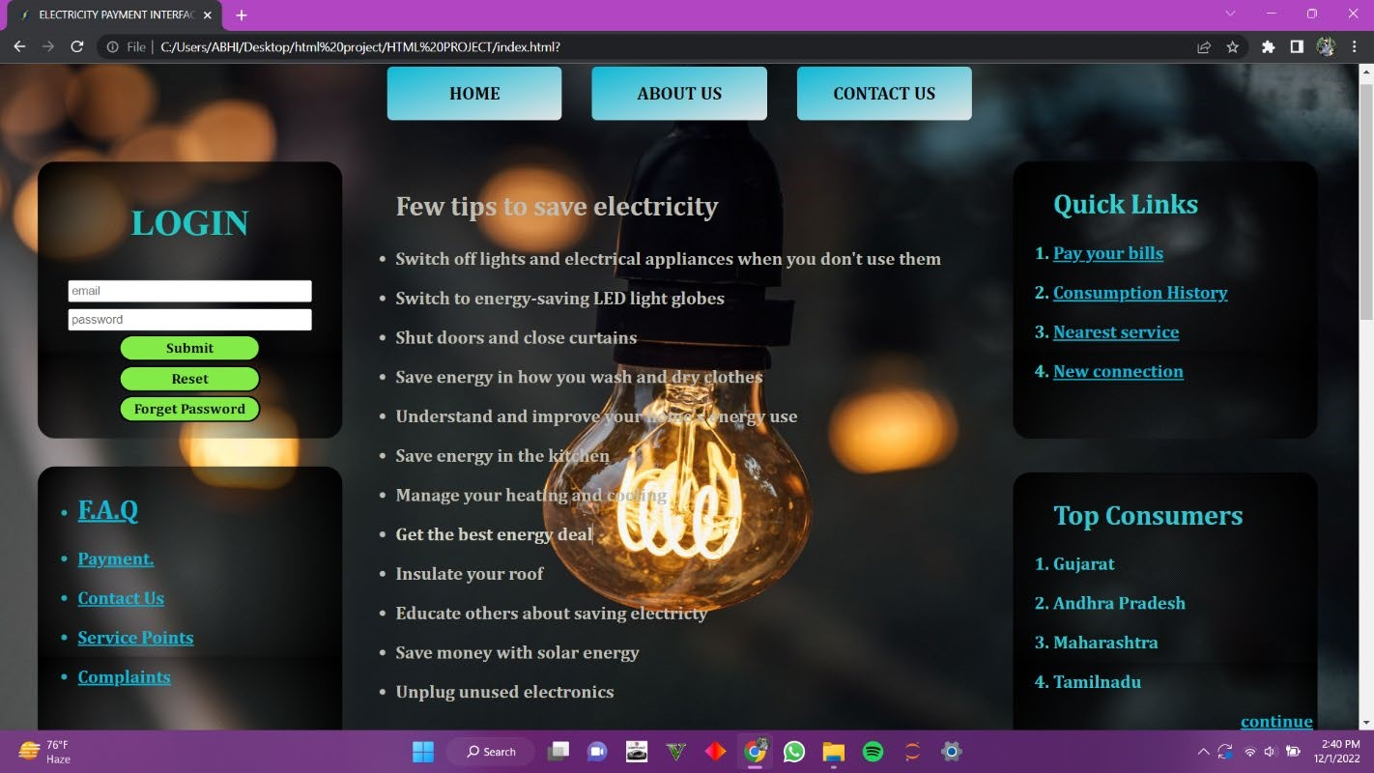

**PAYMENT INTERFACE**

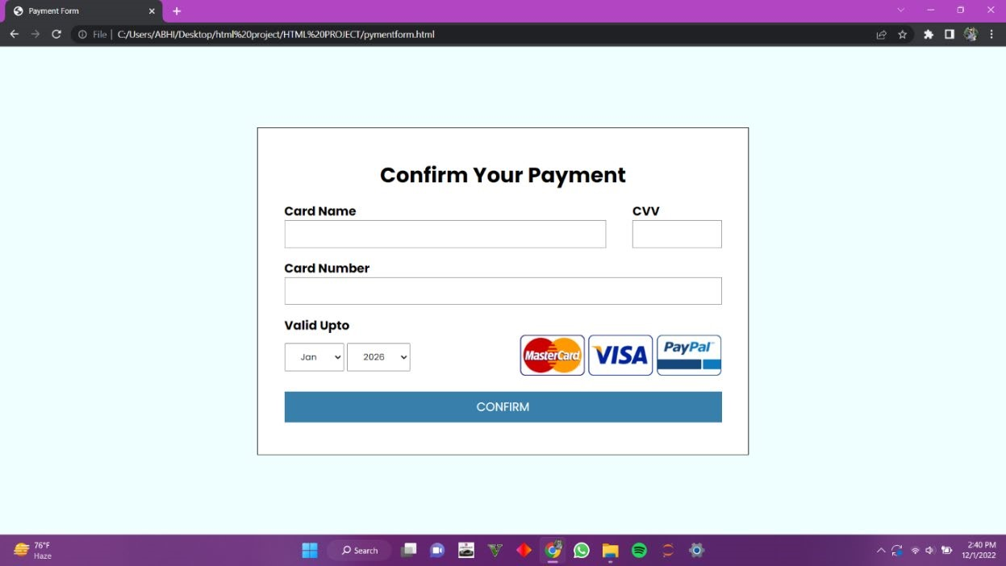

**ABOUT US**

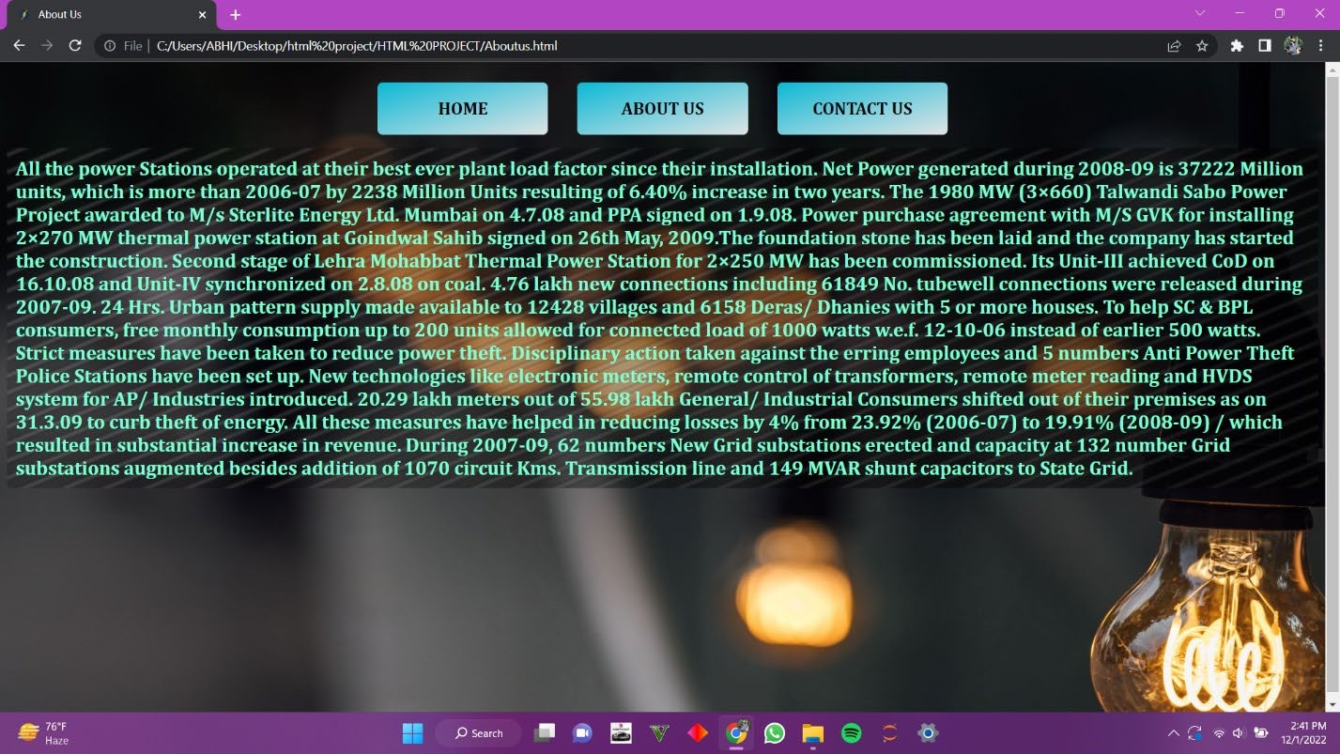

**CONTACT US**

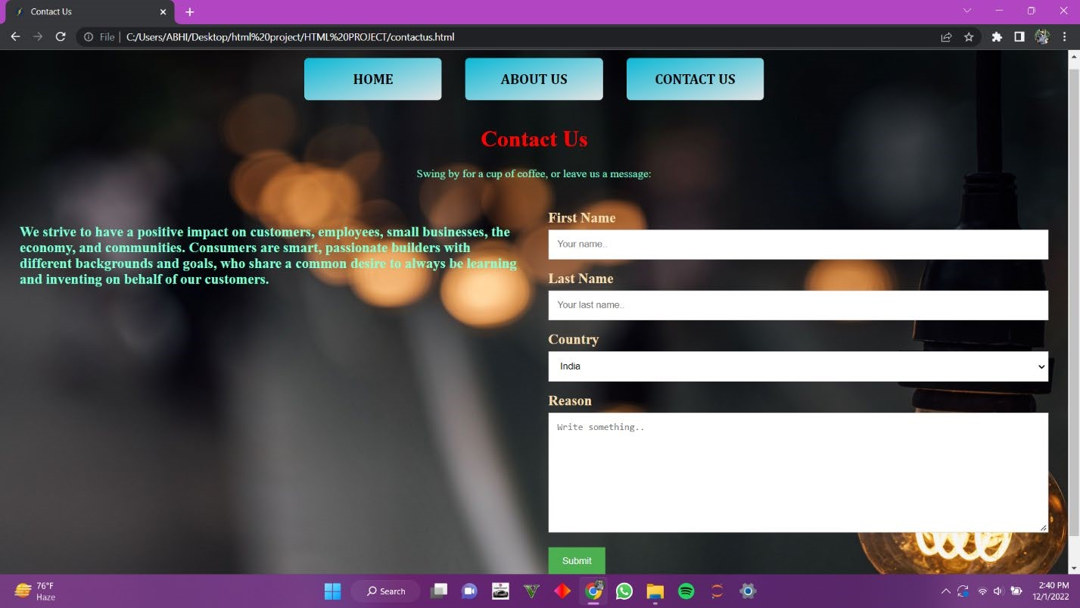

**CONTRIBUTION OF GROUP MEMBER**

**ABHINAY GOUD(12201930):-**

**WEBPAGEs:**

**Home Page**

**About Us**

**AAMIR ADNAN(12201985):-**

**WEBPAGES:**

**Payment Page**

**Login Page**

#### SHIVA REDDY(12201954):-

**WEBPAGES:**

**Contact page**

**F.A.Q Page**

# CONCLUSION

Future of project:

Electronic billing systems have been transformative in the marketplace. Mailed payment processes are demanding in time, cost, and labor. Overwhelmed administrative teams spent hours sifting through individual client data, wasting company time and resources. The implementation of electronic billing systems centralizes consumer data, allowing companies and consumers to receive billing and transaction data more readily. Resources utilized during mailing payment processing is repurposed, allowing the company more flexibility with added convenience. Offering “sweeteners” to entice clients in the movement to eBilling, companies ensure the shift gains traction.**Last but not the least we can complete the work of Backend in the future then this website will be the best for the bill payment and can be used in diffrent companies**.

# REFERENCES

* W3 Schools
* Geeks For Geeks
* Wikipedia